Spring Boot

Session one

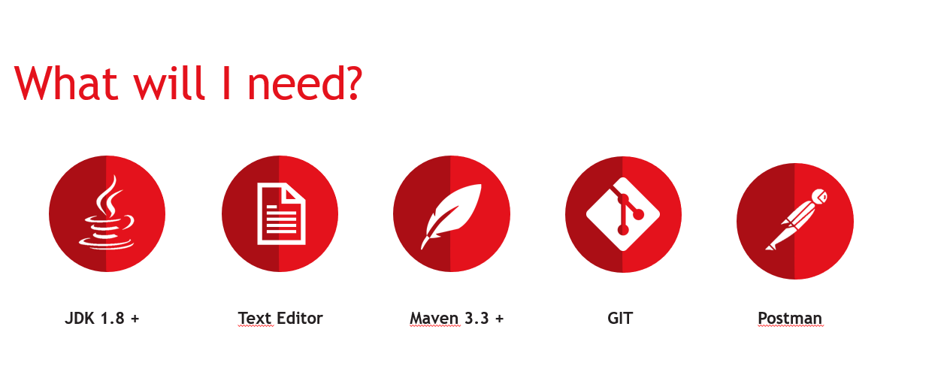

* Intellij recommended

1 - Change the maven settings file to the maven settings from git

2- Change project version to Java 8

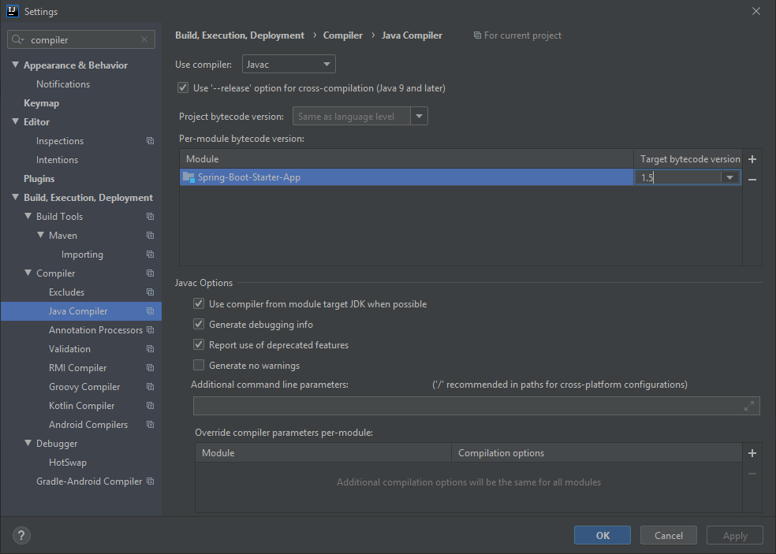

3- Add data storage service in a database using a repository.

4- Add relevant values to item repository

5- Create a person repository to hold information related to the user that’s buying the items.

6 – Create a new ” CreateUserRequestDto” and “CreateUserResponseDto” with relevant properties to create and save users that buy items. Using Lombok, to avoid have to manually create constructors, getters and setters, with the relevant annotations.

7 – Make RestcontrollerAdvice return properly handled errors with buildErrorMessageResponseEntity() method like: “public ResponseEntity<ErrorMessage>”;

8 – Add a new Logger to all classes using the lib “org.slf4j”.

9 – Log relevant information using distinct logger levels.

10 – Update the “com.training.springbootbuyitem.service.ICrudService”, add possibility to load and update list of items.

11 – Remove unused imports from the classes.

12 – Add session info and create a new protect rout for logged users. Block access to anonymous customers.

13 – Add relevant postman requests to test the solution.